[ MLOps+DevOps ] Task – 2

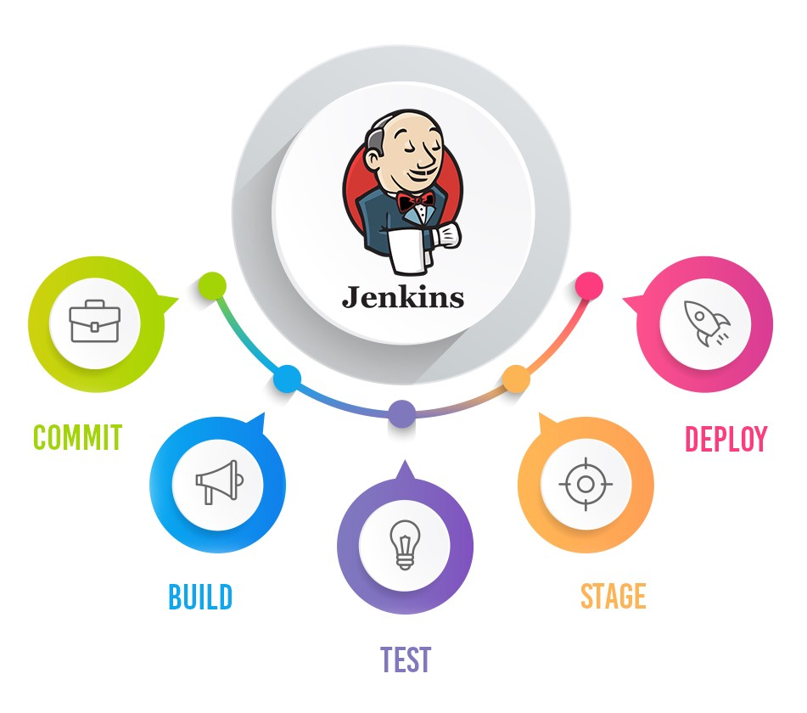

**Deployment Automation with Jenkins, Docker, Git and GitHub on RedHat**

### Used a Dockerfile to create a container image having Jenkins installed and start Jenkins service automatically, container when launched.

Create a Dockerfile .

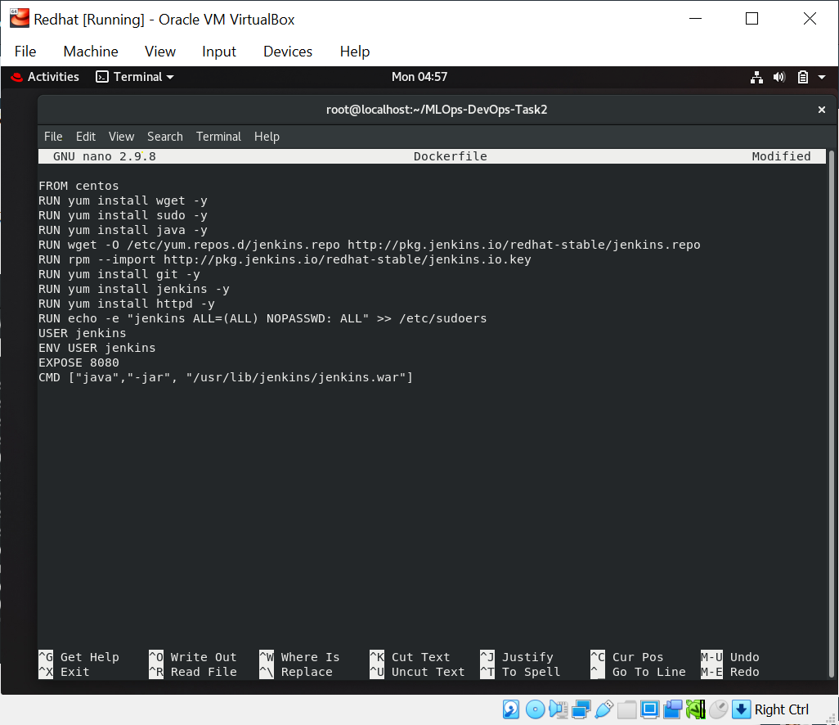

Build the docker image using the below command.

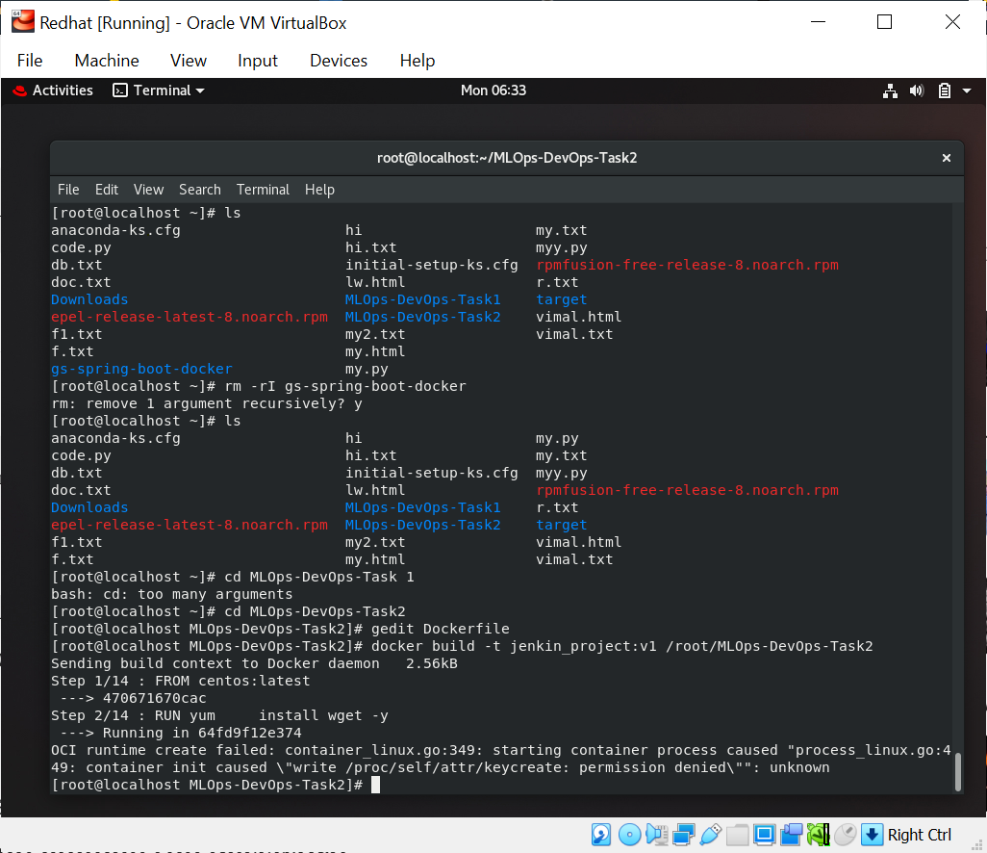

Complete the installation process of Jenkins. For this, we will need an initial Admin Password . Copy-paste the Password and complete the installation process. 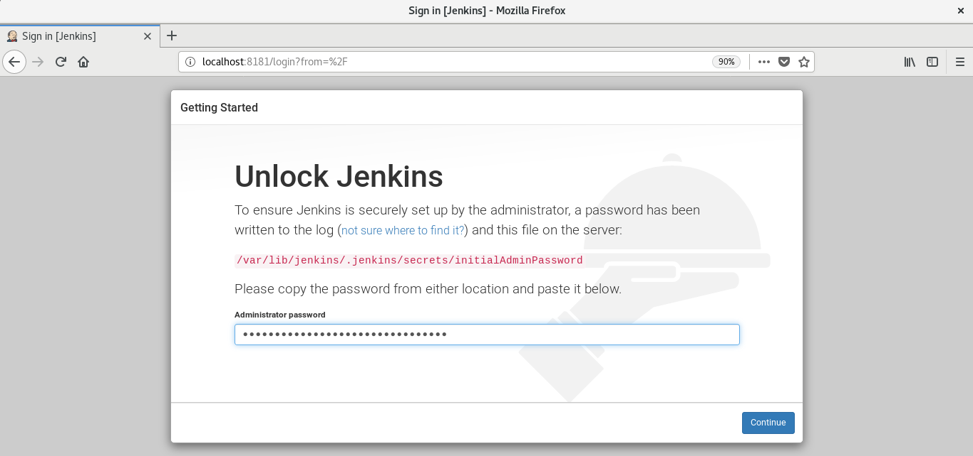2. Creation of job chain of job1, job2, job3 and job4 using build pipeline plugin in Jenkins

**Job1:** Pull the Github repo automatically when some developers push the repo to Github. For this, we expose port 8181 on which Jenkins is running to the outer world using ngrok.

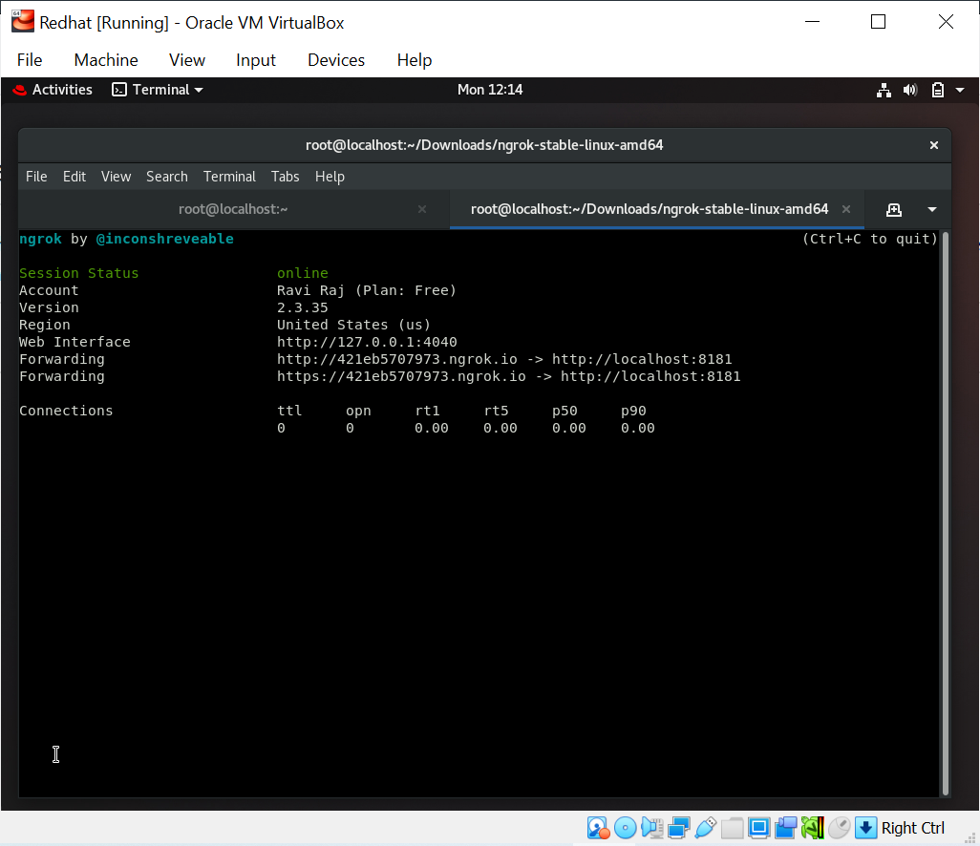

Create a webhook in GitHub. So, go to Webhook settings and enter the Jenkins URL + /github-web/hook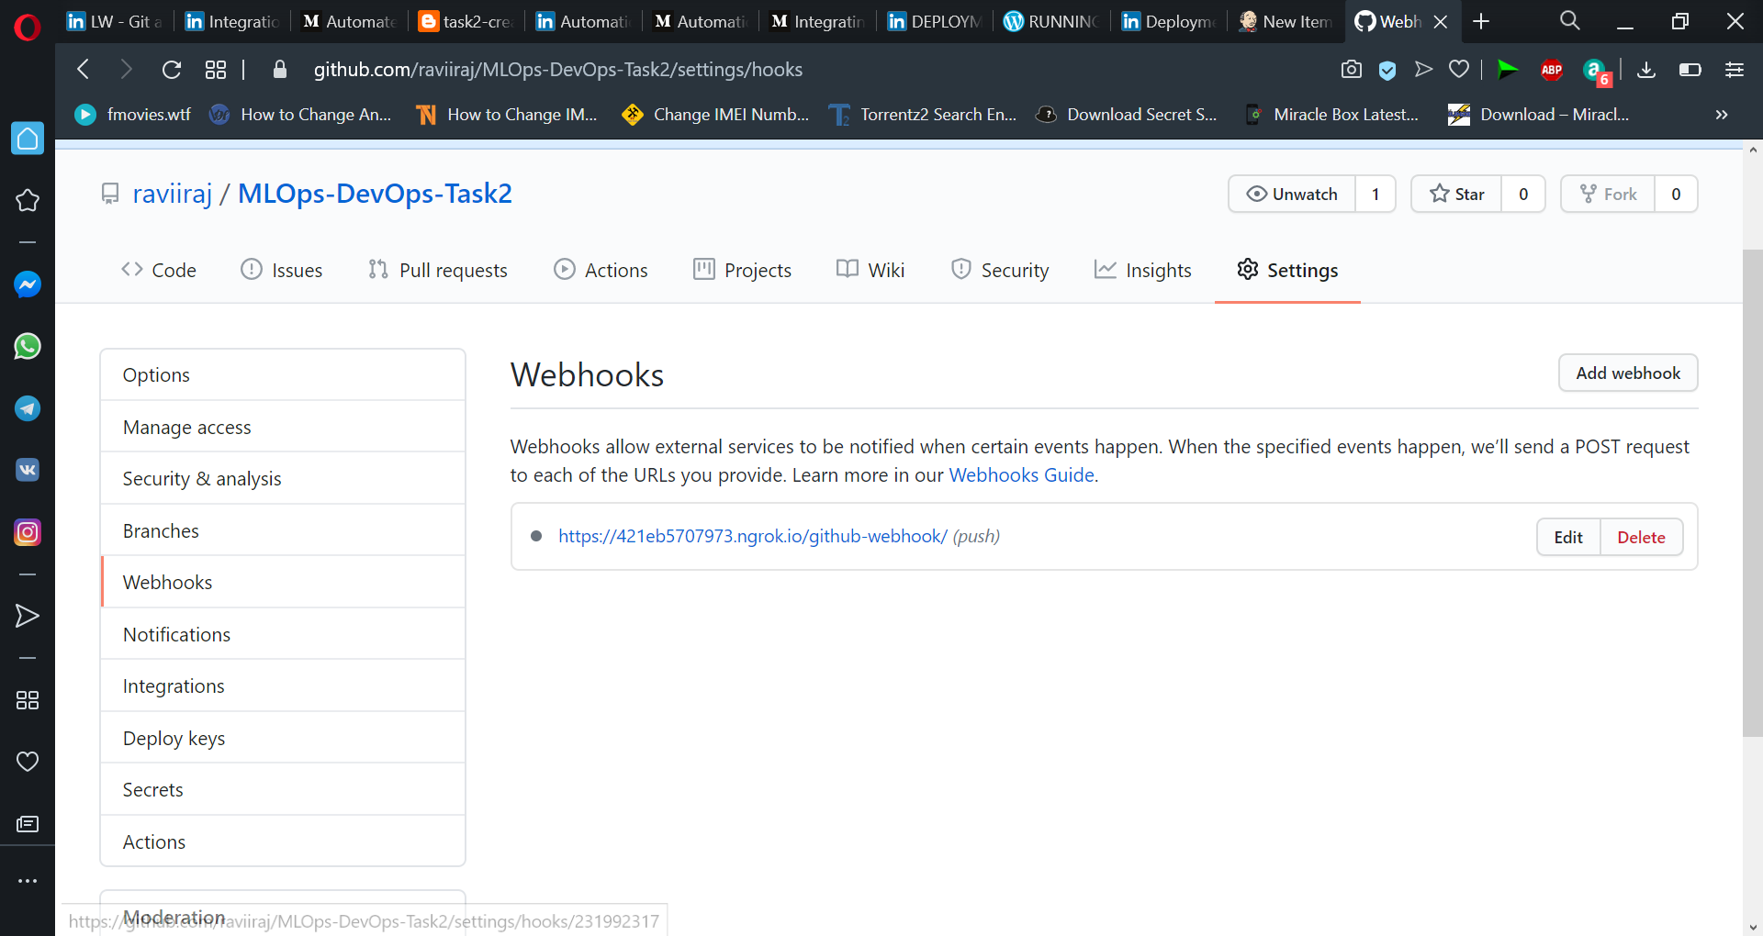

Create the Job in Jenkins.

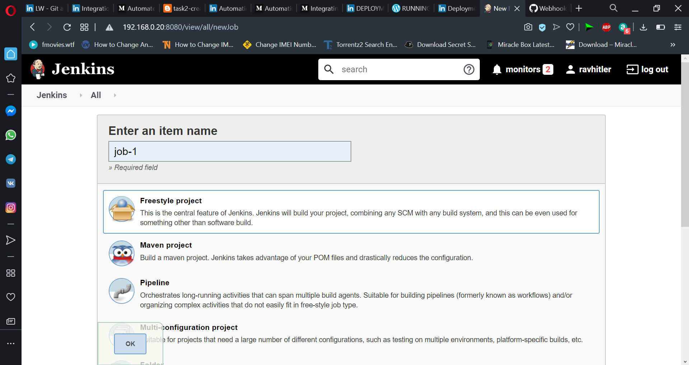

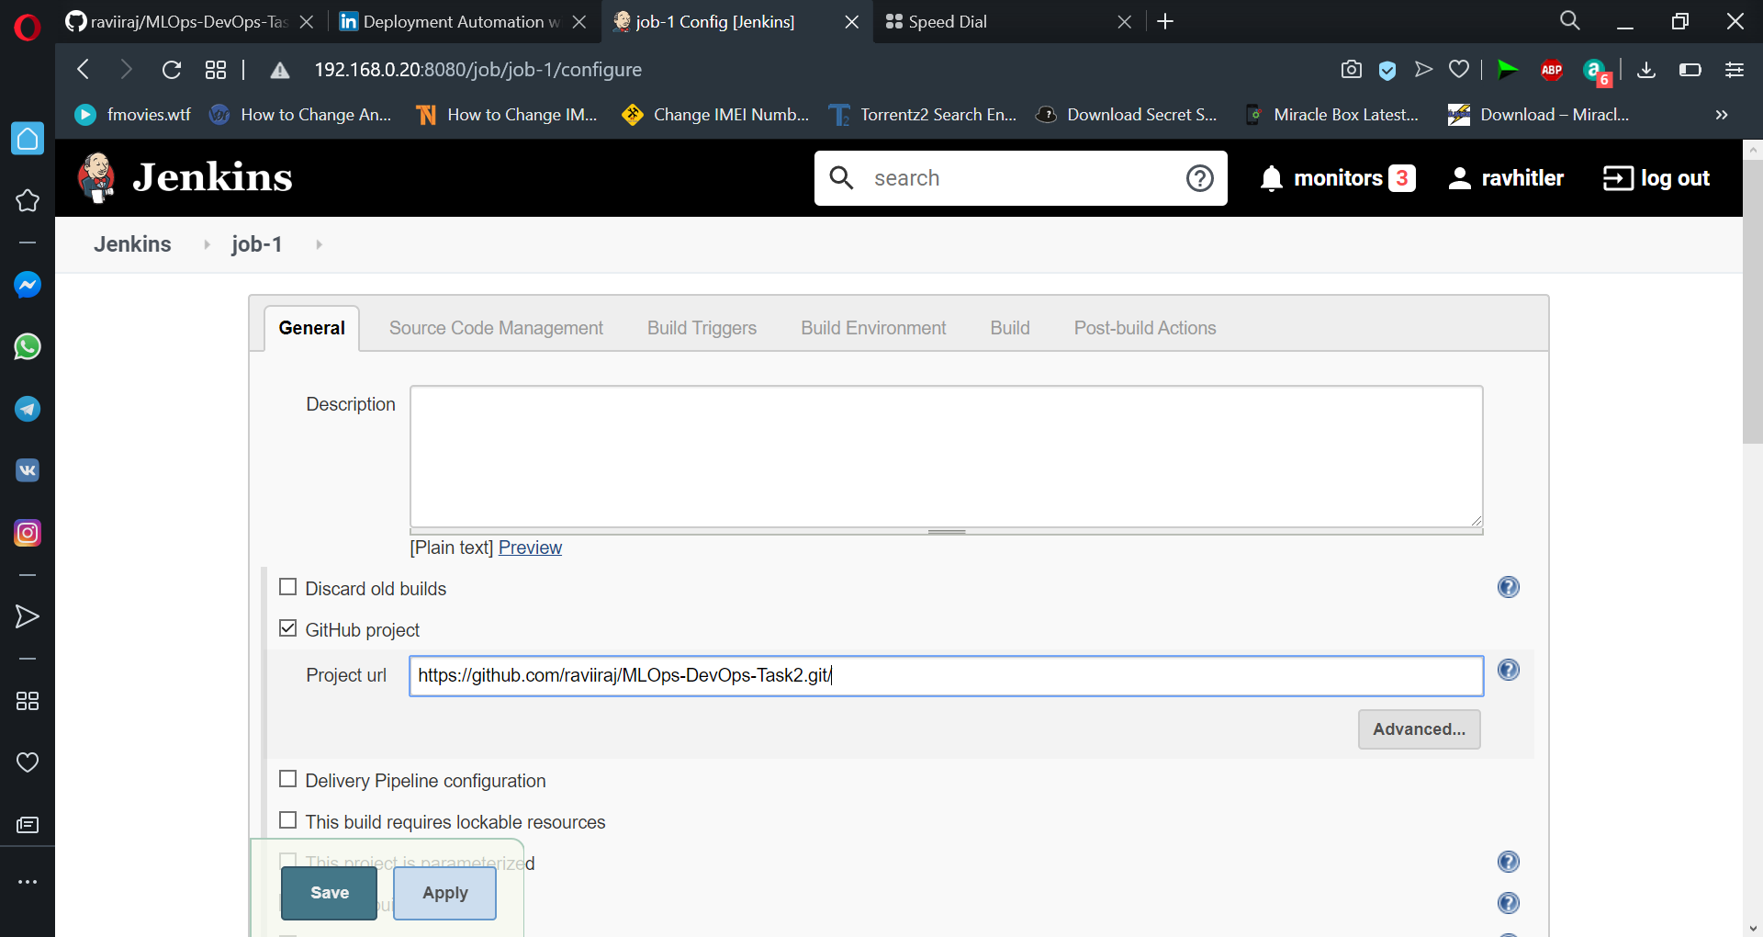

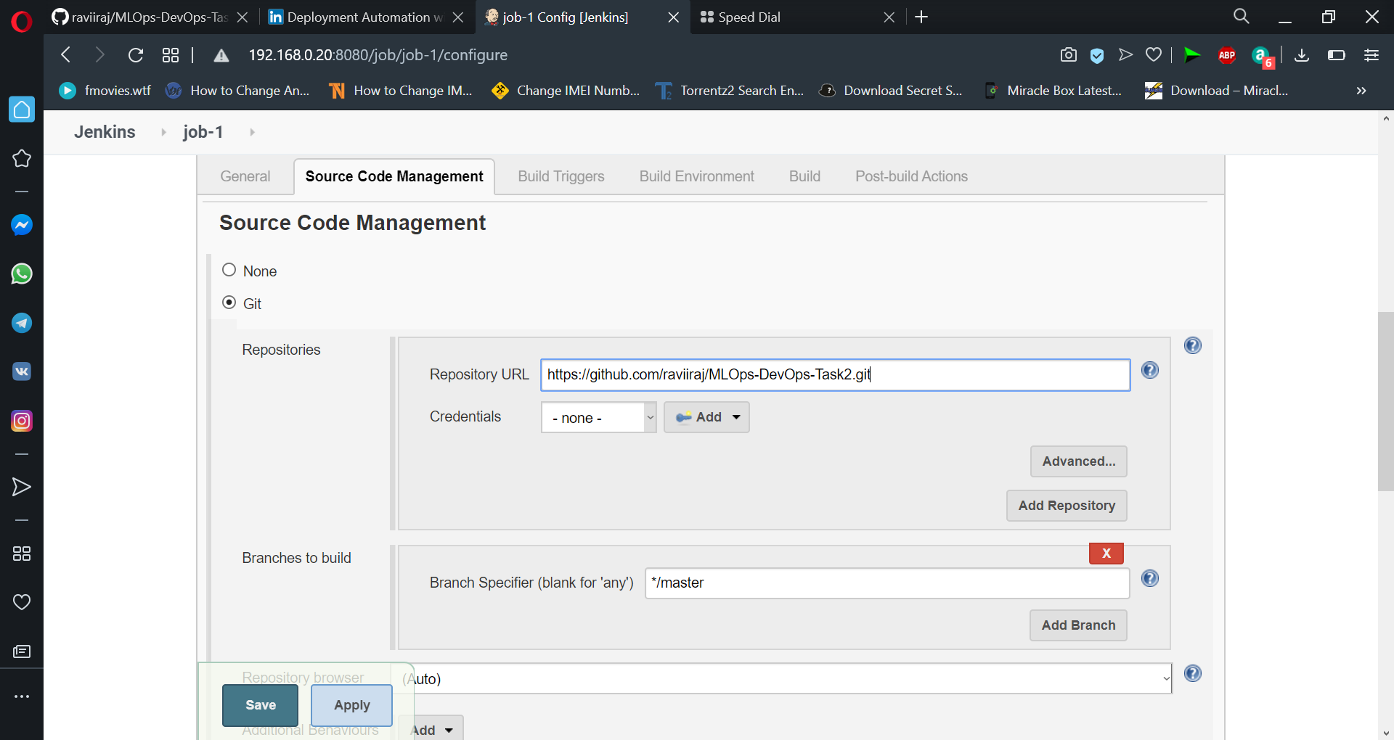

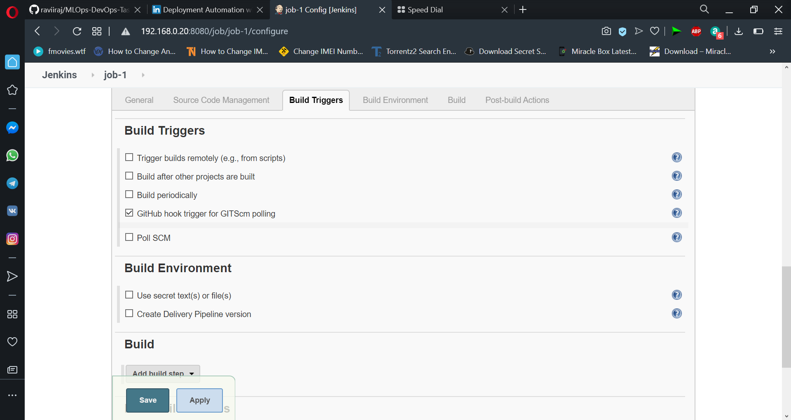

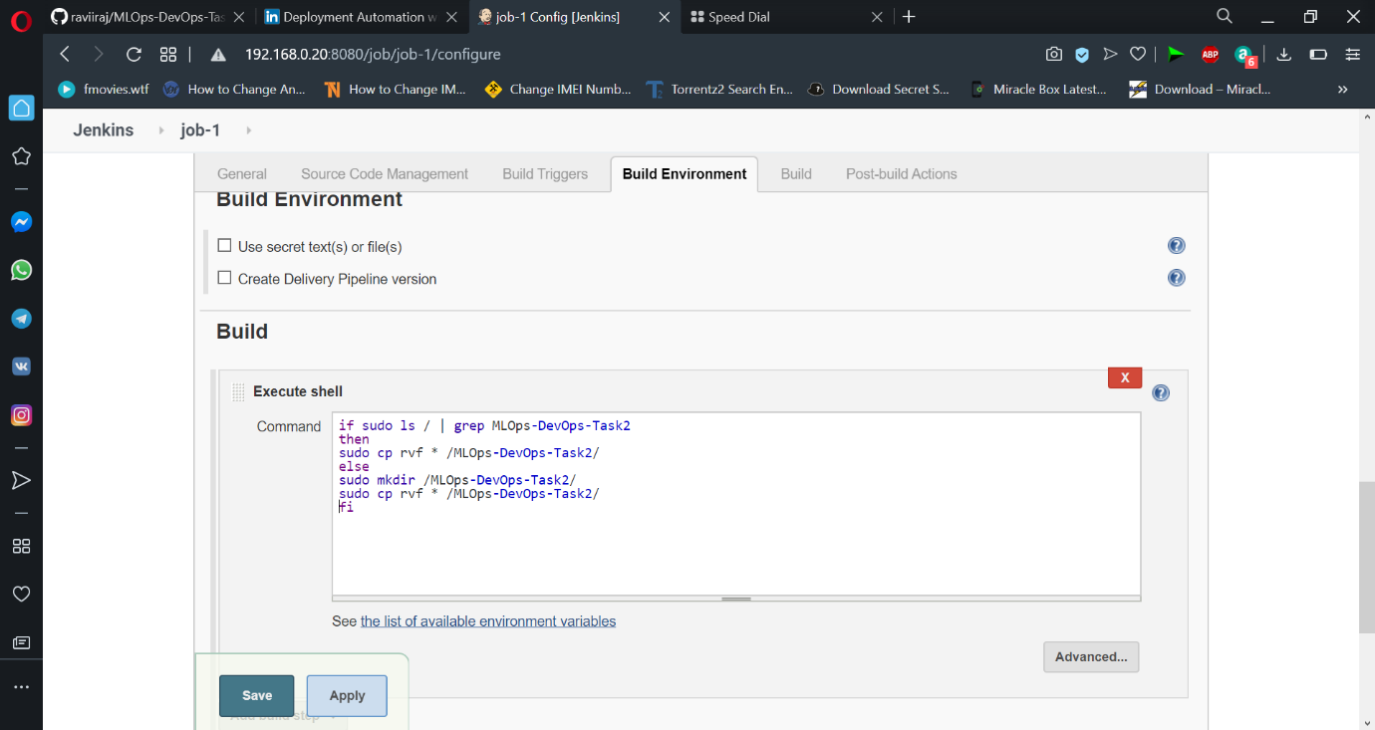

**#Job-2**  Jenkins should automatically start language interpreter install image container to deploy code. Create second Job in Jenkins to deploy a suitable container and the code.

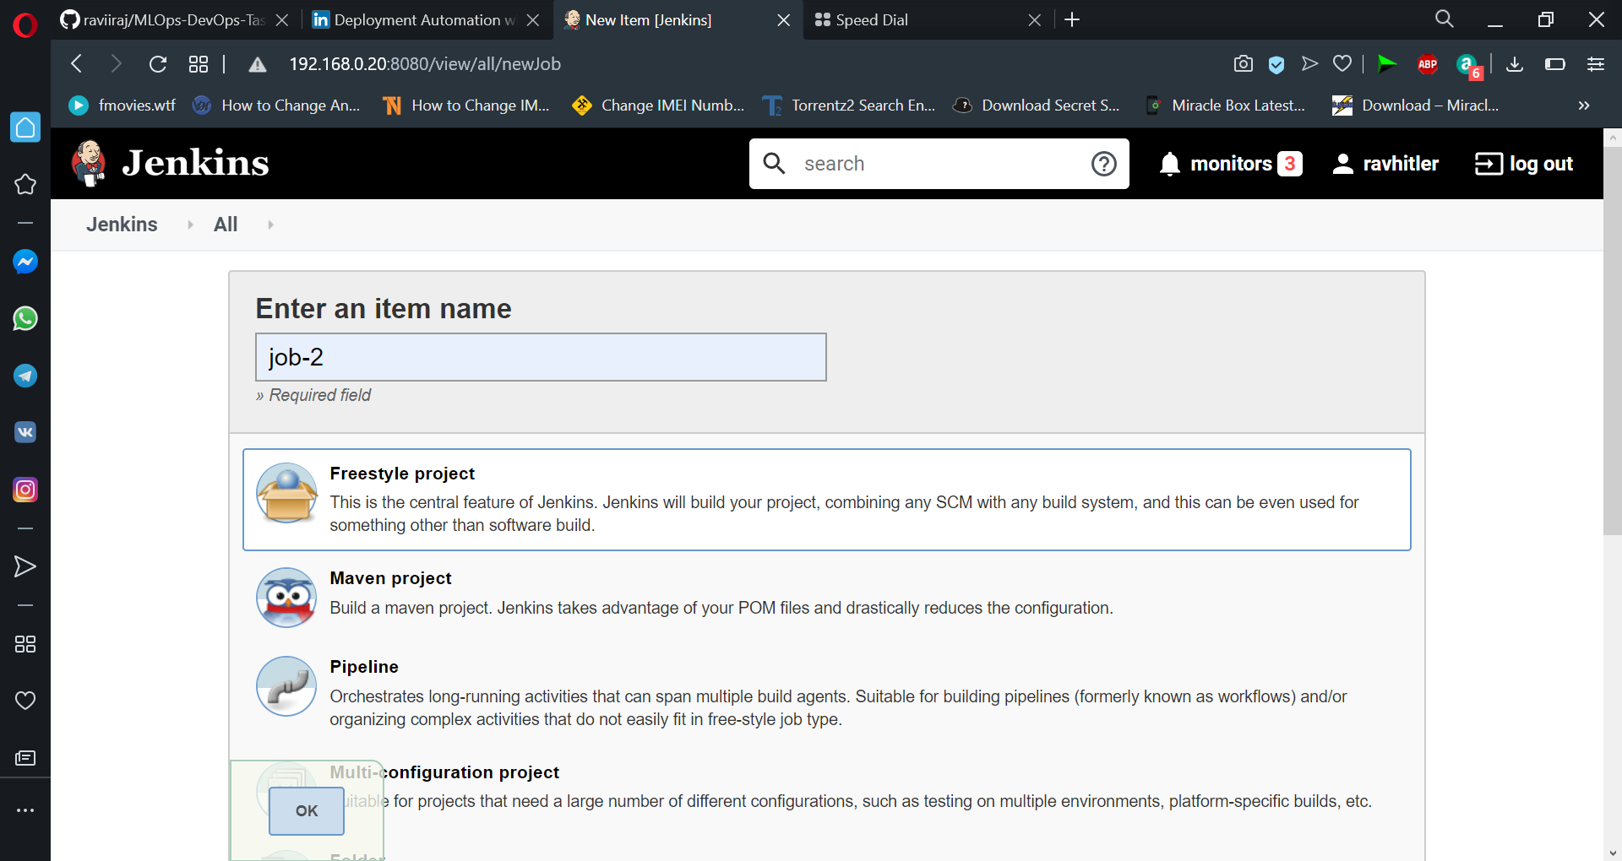

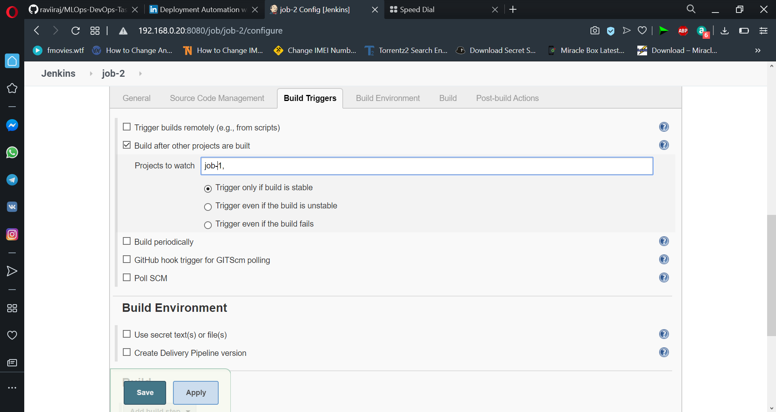

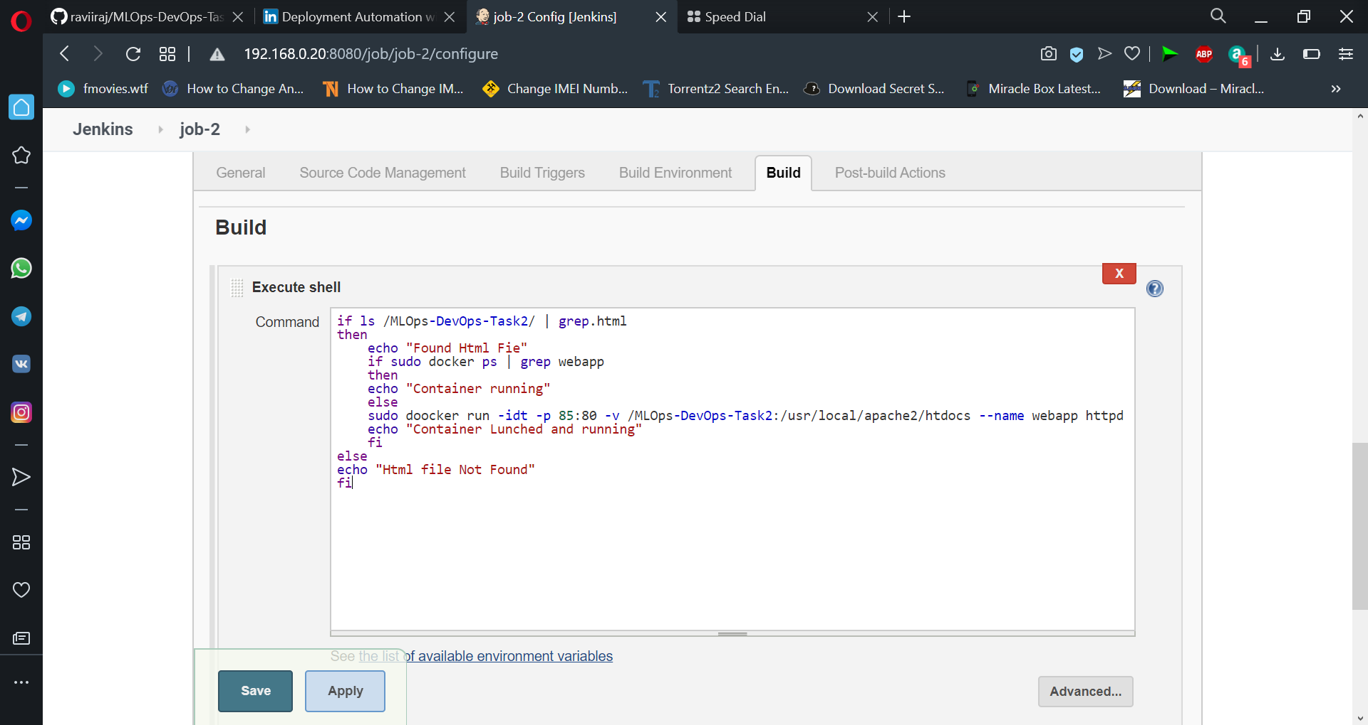

**#Job-3** Test your app is working or not.

We will check if the HTTP code of our site is 200 which means our app is running successfully. And then set STATUS_CODE environmental variable as 0 or 1 accordingly.

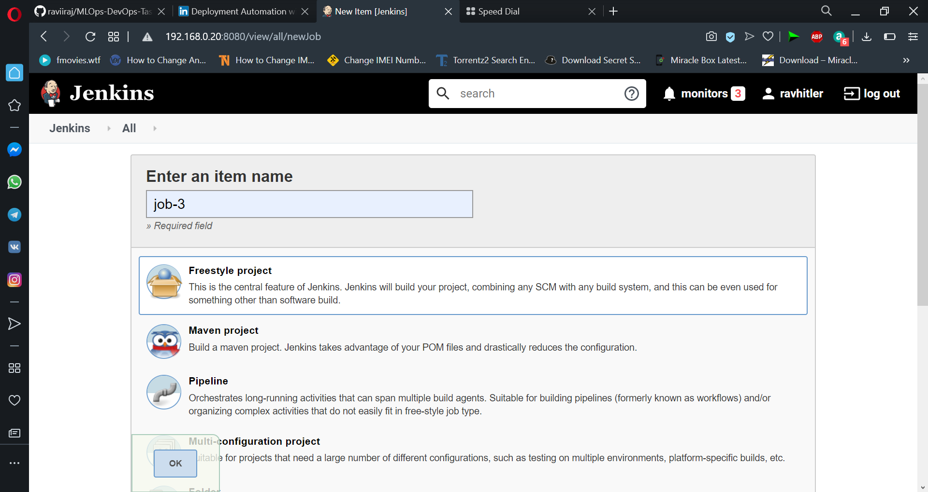

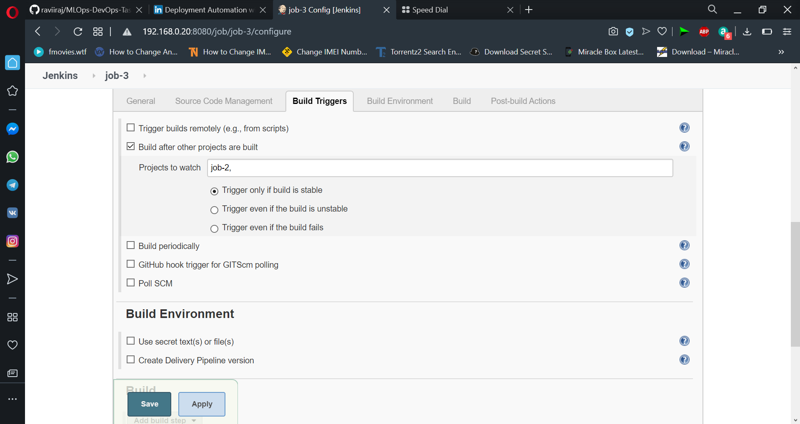

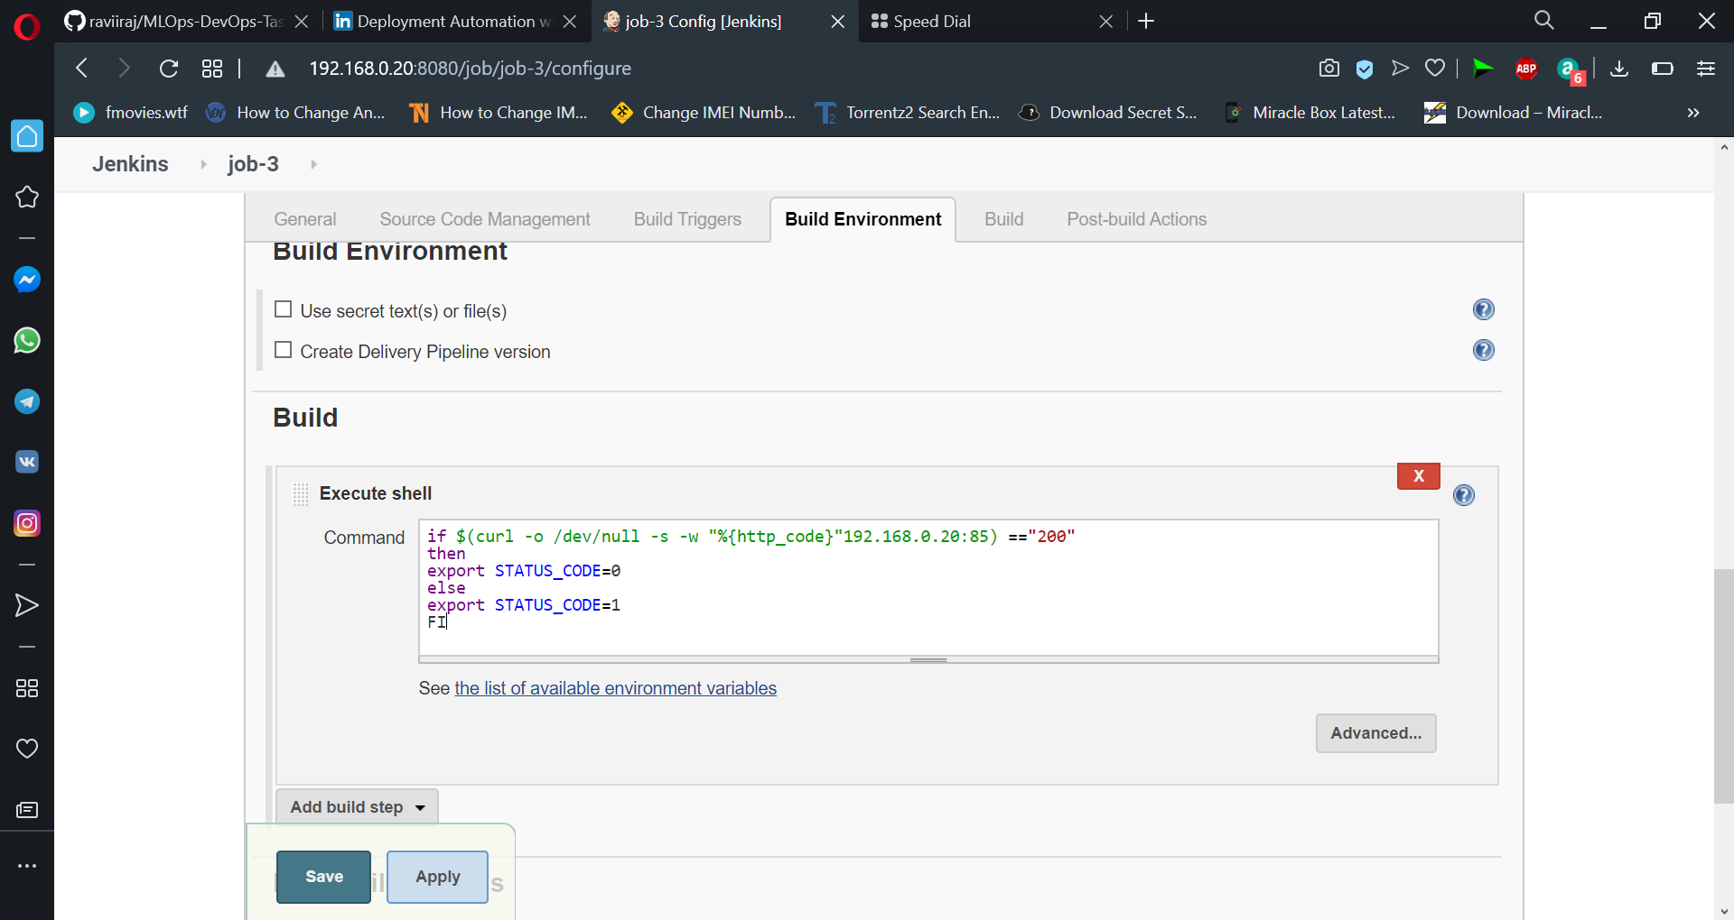

**#Job-4** If app is’nt working, then send an email to the developer with error messages. At the end for our fourth job, we will check the STATUS_CODE environment variable and send the email accordingly.

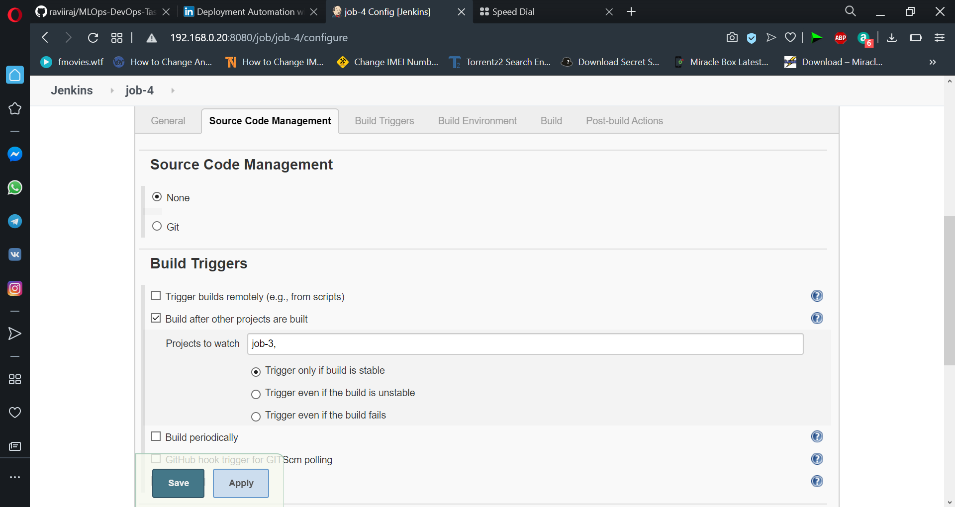

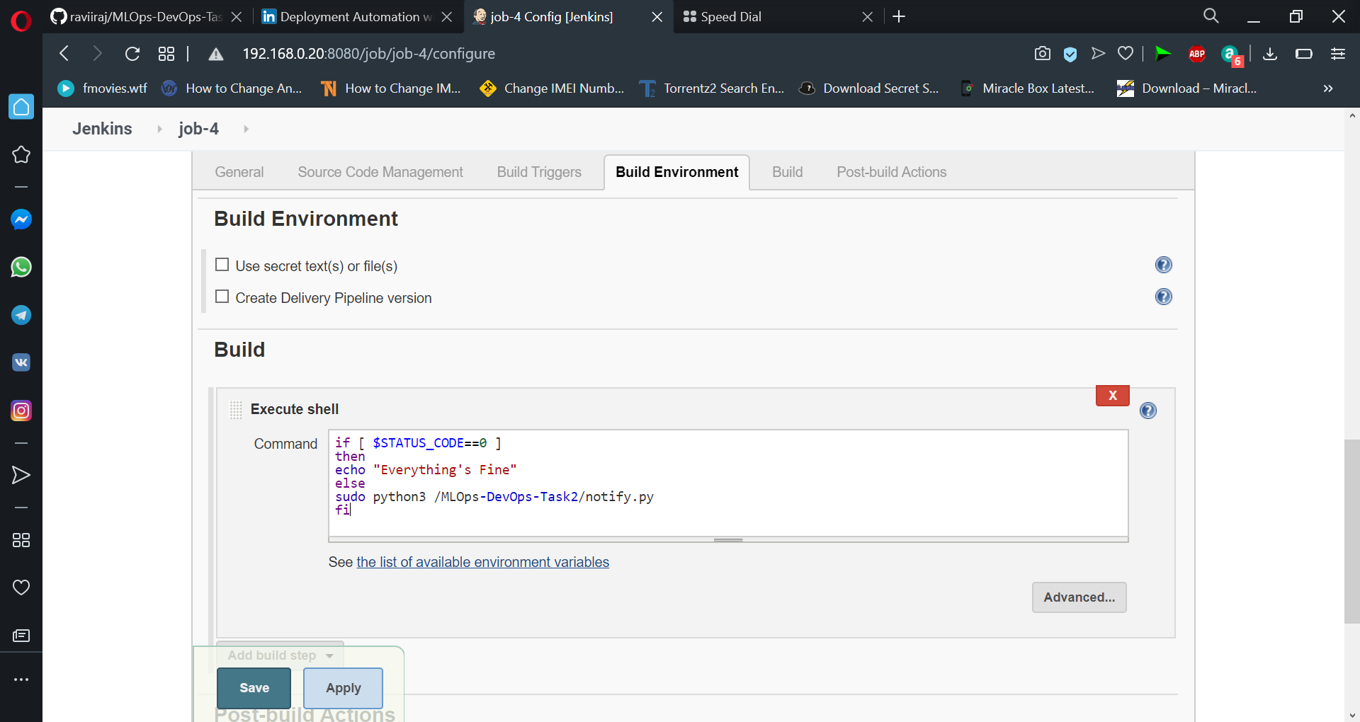

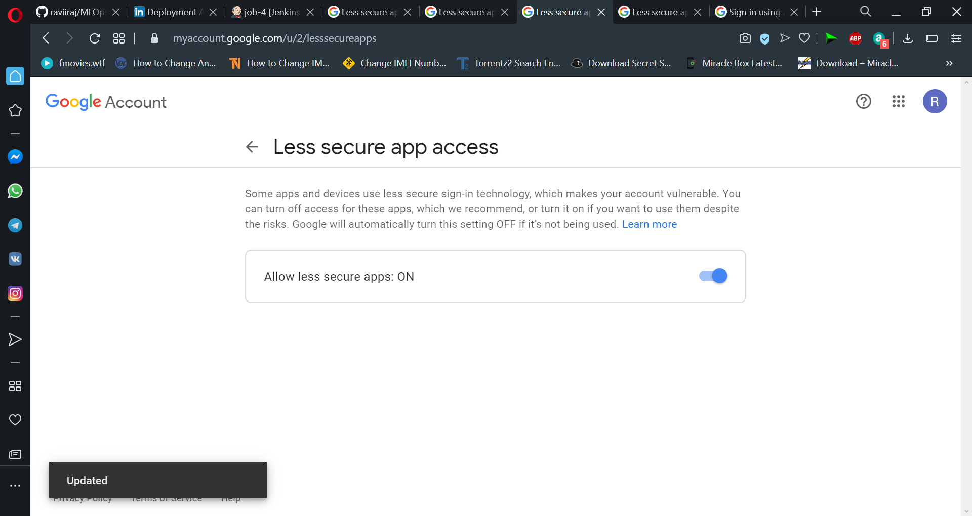

You’ll receive a Failed mail.

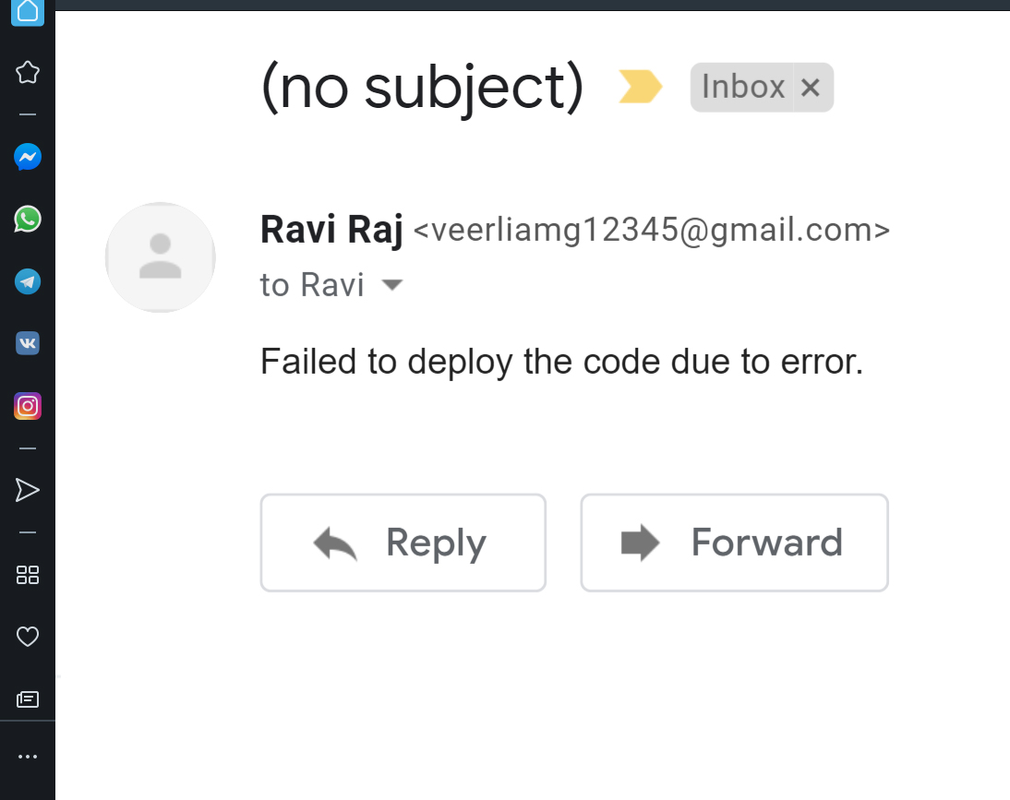

### Create an extra job

**#Job-5(For Monitor)** If the container having running app fails due to any reason then this job should automatically start the container again. So, We are going to Schedule our job to check every minute.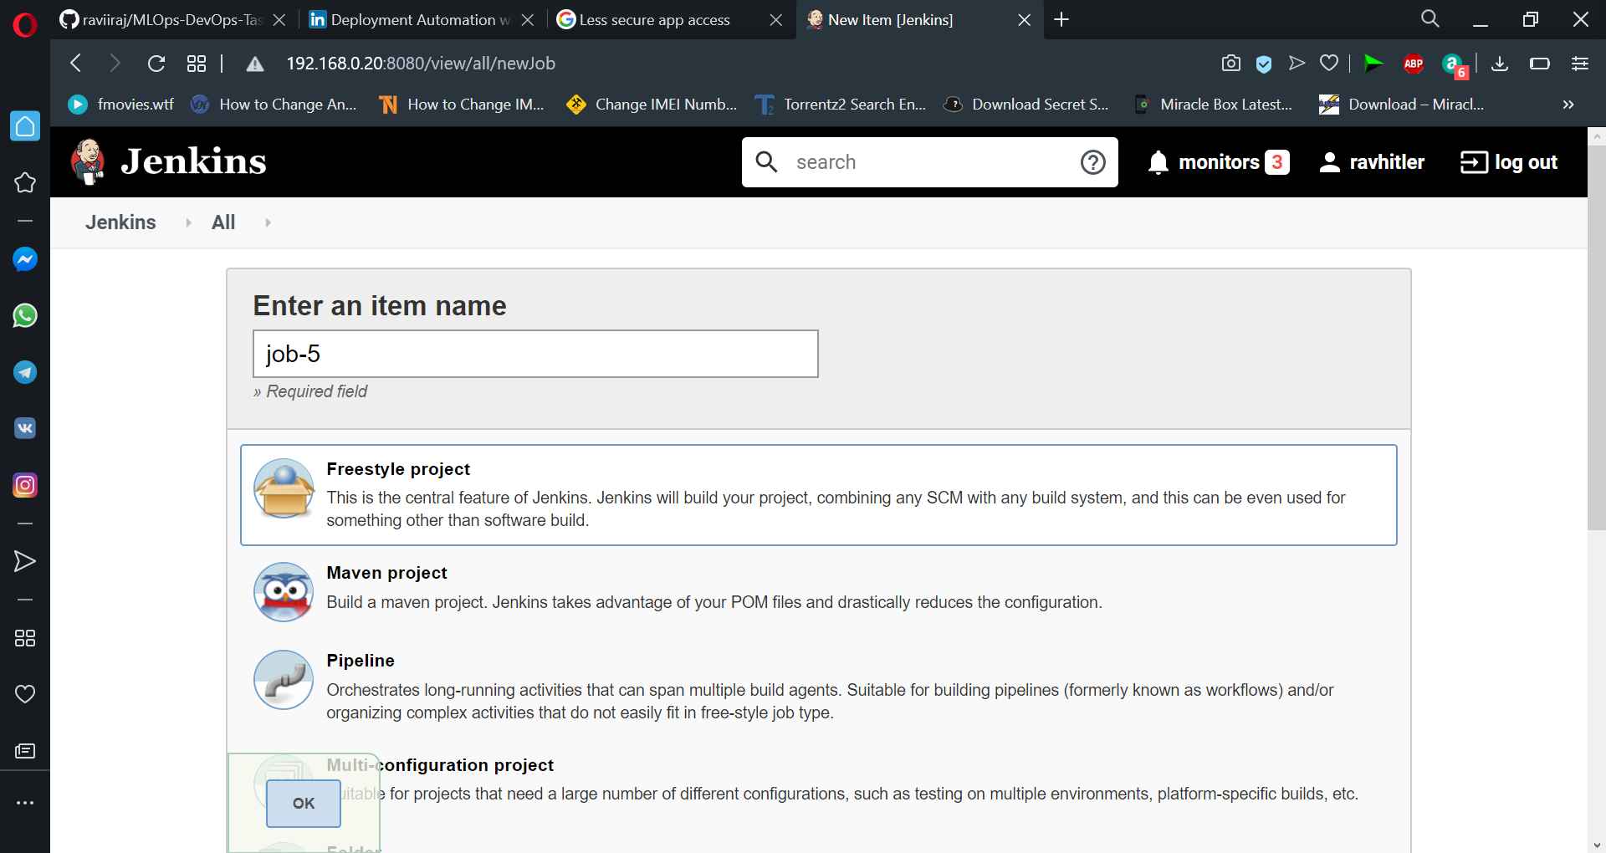

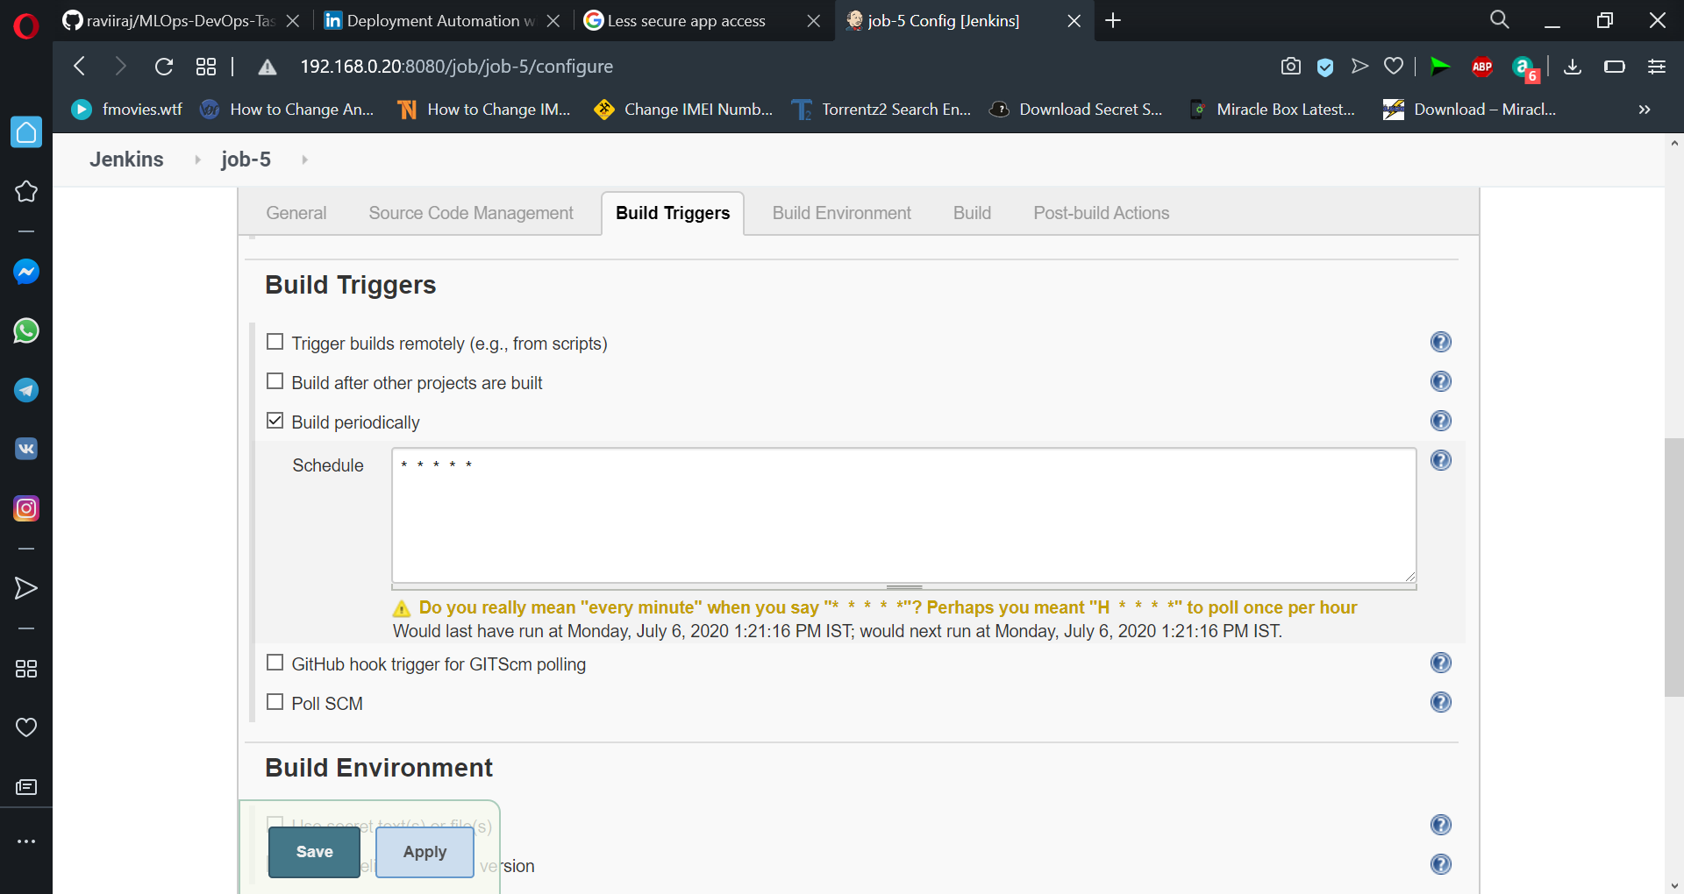

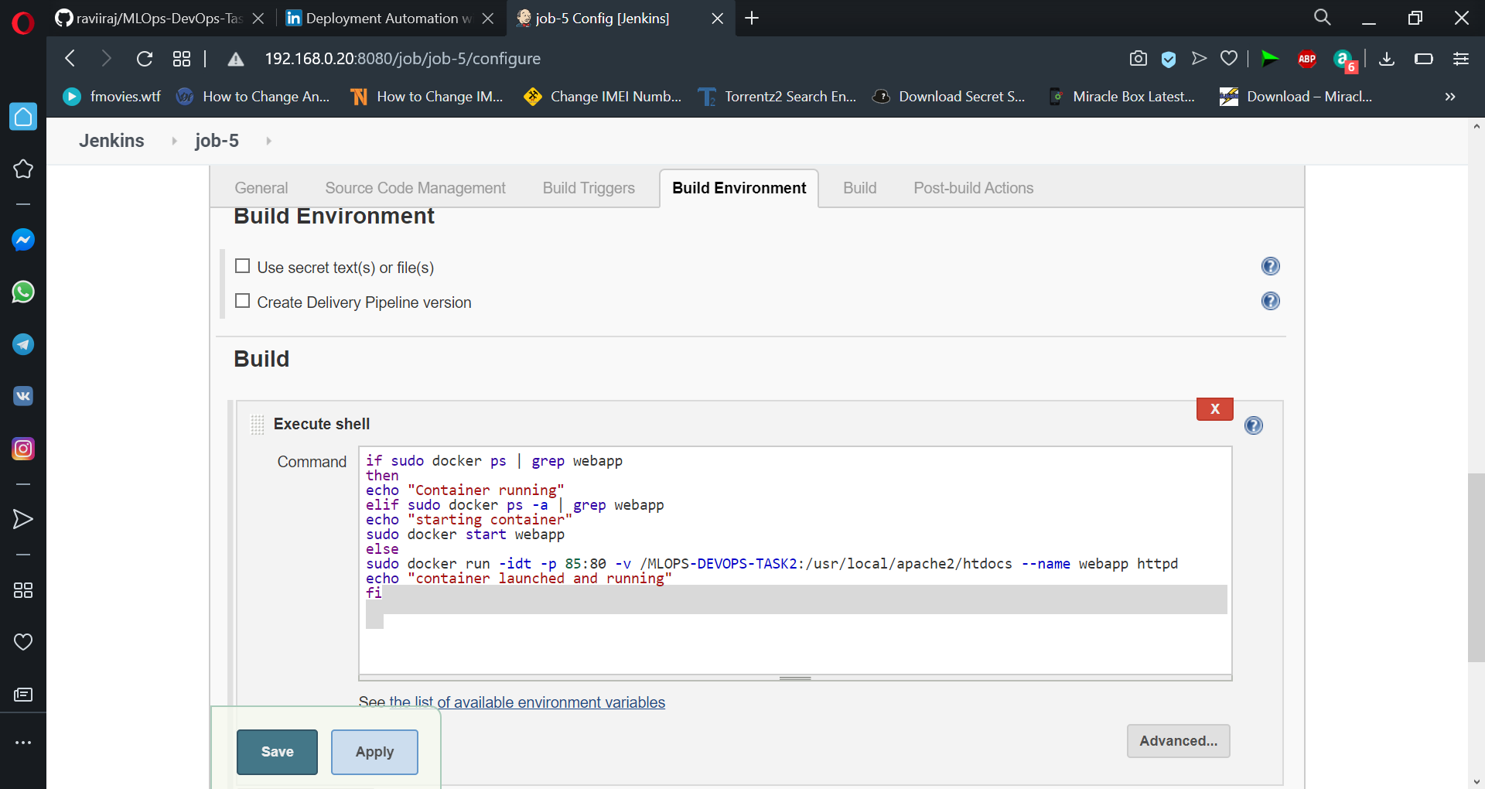

Click Apply and Save it. We have completed our task.

Let's push a change in our web page to trigger the automation process.

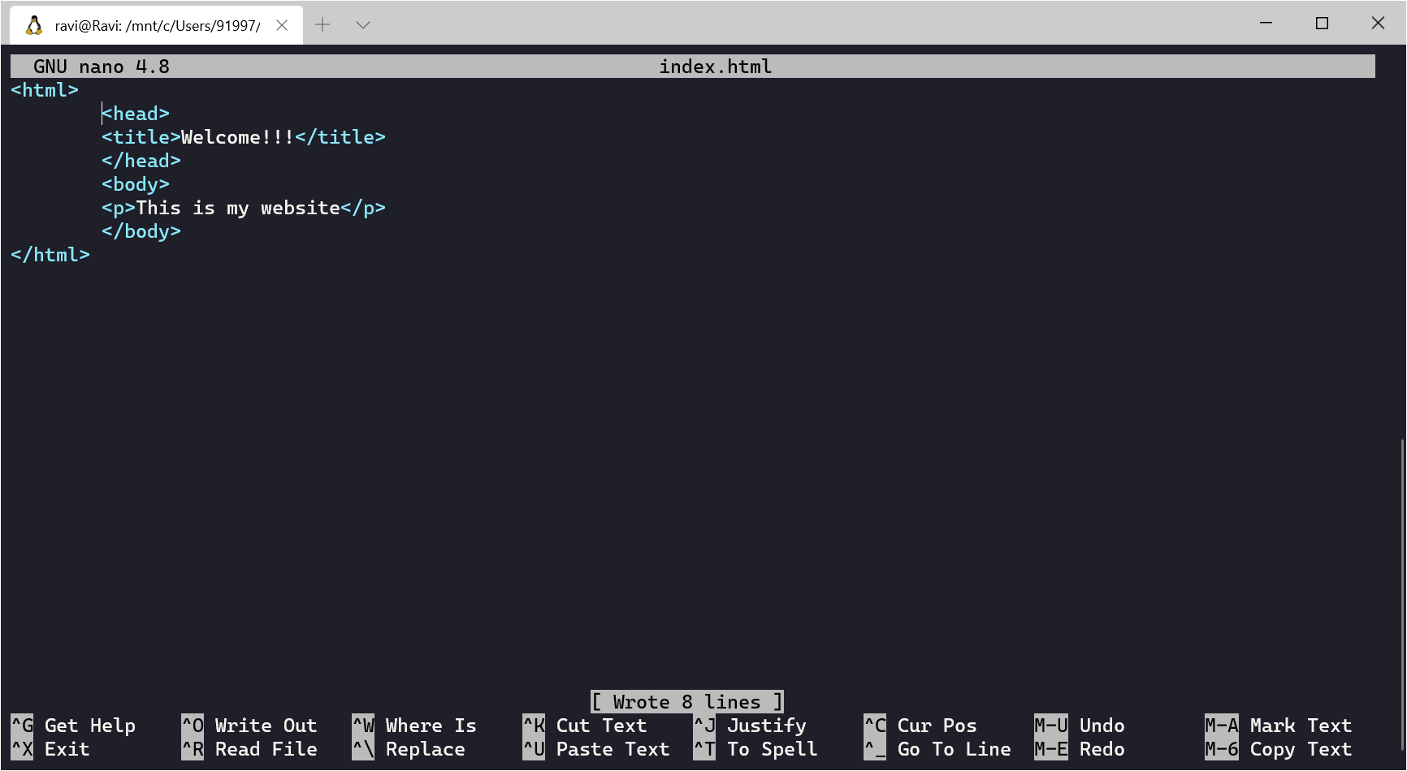

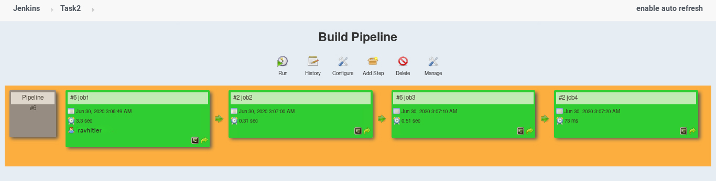

And the site is shown as

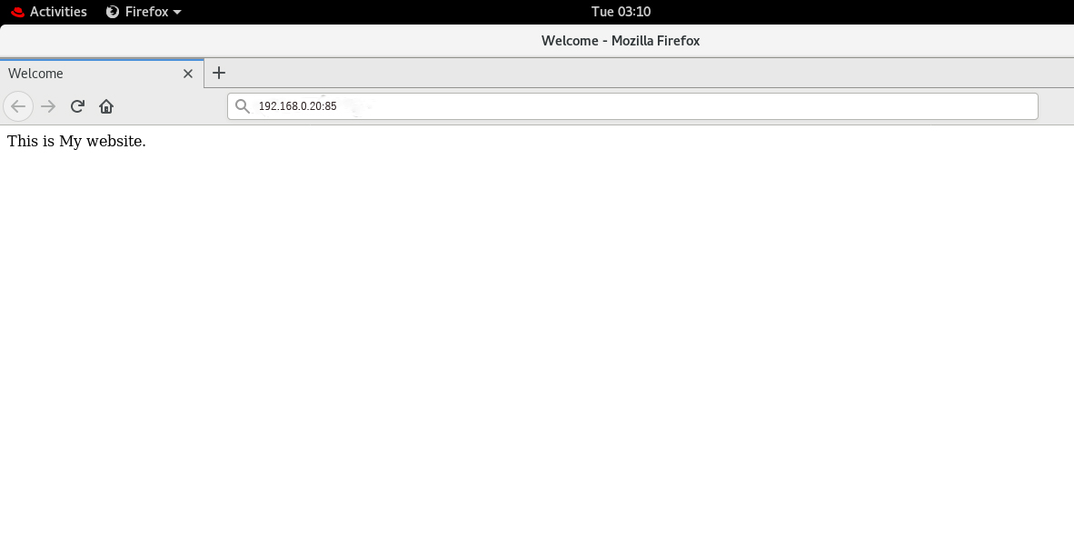

That’s all, the task-2 of mlops and devops is completed. It took much time to figure out things, but lastly I did it. Thanks to vimal sir for teaching such interesting technologies to us.